**SUPERIOR UNIVERSITY LAHORE**

|  |
| --- |
| Superior Logo |

**Faculty of Computer Science & IT**

**FINAL YEAR PROJECT**

**PROJECT IDEA**

**Colony’s Record Management**

Project ID: **[Issued by FYP Manager]**

**Project Team**

|  |  |  |  |  |
| --- | --- | --- | --- | --- |
| **Student Name** | **Student ID** | **Program** | **Contact Number** | **Email Address** |
| M. Usman | BCSM-S17-006 | BCS | +923354070136 | bcsm-s17-006@superior.edu.pk |
| Adeel Ali | BCSM-S17-019 | BCS | +923349782003 | bcsm-s17-019@superior.edu.pk |
| M. Usman Tahir | BCSM-S17-014 | BCS | +923056295540 | bcsm-s17-014@superior.edu.pk |

**[Project Supervisor]**

Mr. Waseem Arif

**[** Assistance Professor]

**Project Report**

**Colony’s Record Management**

**Change Record**

|  |  |  |  |  |
| --- | --- | --- | --- | --- |
| **Author(s)** | **Version** | **Date** | **Notes** | **Supervisor’s Signature** |
|  | 1.0 |  | <Original Draft> |  |
|  |  |  | <Changes Based on Feedback from Supervisor> |  |
|  |  |  | <Changes Based on Feedback From Faculty> |  |
|  |  |  | <Added Project Plan> |  |
|  |  |  | <Changes Based on Feedback from Supervisor> |  |
|  |  |  |  |  |
|  |  |  |  |  |
|  |  |  |  |  |
|  |  |  |  |  |
|  |  |  |  |  |

**APPROVAL**

|  |  |
| --- | --- |
| **Project Supervisor** | |
| Comments: ___________________________________________________________________ | | |
| _____________________________________________________________________________ | | |
| Name:______________________________ |  | |
| Date:_______________________________ | Signature:__________________________ | |

|  |  |
| --- | --- |
| **Project Manager** | |
| Comments: ___________________________________________________________________ | |
| _____________________________________________________________________________ | |
|  |  |
| Date:_______________________________ | Signature:__________________________ |

|  |  |
| --- | --- |
| **Head of the Department** | |
| Comments: ___________________________________________________________________ | |
| _____________________________________________________________________________ | |
|  |  |
| Date:_______________________________ | Signature:__________________________ |

# Dedication

*We dedicate our work of final year project to our respectful teachers, parents and friends, who support our project idea and gave us proper guidance regarding our project, encourage us in every step we took forward in completion of the project. Without their cooperation it would have not been possible to achieve this goal. Specially our teachers who support us and taught us little things that helped us a lot towards our progress. We will always appreciate all of them and remember them in our good books.*

# Acknowledgements

**[“Allah elevates to high positions those from amongst you who are faithful and those who have acquired knowledge “]** (Quran, 58:11)

We really thankful to our FYP Maneger (Zaman Aziz) as well as Supervisor (Waseem Arif), who gave us the golden opportunity to achieve our goal and who gave us continuous guidance, assistance, and inspiration to continue efficiently working on our project and obtain promising results. During this work CRM (Colony’s Record Management) we have learnt a lot of things, do a maximum research and came to know about many new things which will help us in future In-Shaa-Allah.

Last but not least, we would like to present a special thanks to our families, for their love, understanding, encouragement, and confidence in us.

# Executive Summary

We are developing a web-site which holds record of a colony. The web-site will keep the detail record of all the members of the colony, vehicles belonging to members of colony Incoming and outgoing vehicles as well as the visitors to and from the colony with respect to the time. In addition, the website will also have a module as property classified through which the visitors of the website will get the information of property on sale/ rent.

The objective of this project is to develop a web-site in which every member of society should be recorded their entry or leaving time from society and their vehicle’s due to this the security of society would also improve. If anybody wants to complaint against anyone or if they face any kind of problem it helps in investigation by their recorded data. This project will be also useful for the Police Department in case any illegal activity would happens in society they will easily identify the criminals and approached them by their previous history and data. Also, they can use different functionalities of this system like searching properties.

# Table of Contents

Dedication iv

Acknowledgements v

Executive Summary vi

Table of Contents vii

List of Figures ix

List of Tables x

Chapter 1 1

Introduction 1

1.1. Background 2

1.2. Motivations and Challenges 2

1.3. Goals and Objectives 2

1.4. Literature Review/Existing Solutions 2

1.5. Gap Analysis 2

1.6. Proposed Solution 2

1.7. Project Plan 3

1.7.1. Work Breakdown Structure 3

1.7.2. Roles & Responsibility Matrix 3

1.7.3. Gantt Chart 3

1.8. Report Outline 3

Chapter 2 4

Software Requirement Specifications 4

2.1. Introduction 5

2.1.1. Purpose 5

2.1.2. Document Conventions 5

2.1.3. Intended Audience and Reading Suggestions 5

2.1.4. Product Scope 5

2.1.5. References 6

2.2. Overall Description 6

2.2.1. Product Perspective 6

2.2.2. Product Functions 6

2.2.3. User Classes and Characteristics 6

2.2.4. Operating Environment 7

2.2.5. Design and Implementation Constraints 7

2.2.6. User Documentation 7

2.2.7. Assumptions and Dependencies 7

2.3. External Interface Requirements 8

2.3.1. User Interfaces 8

2.3.2. Hardware Interfaces 8

2.3.3. Software Interfaces 8

2.3.4. Communications Interfaces 9

2.4. System Features 9

2.4.1. System Feature 1 9

2.4.1.1. Description and Priority 9

2.4.1.2. Stimulus/Response Sequences 9

2.4.1.3. Functional Requirements 9

2.4.2. System Feature 2 10

2.4.2.1. Description and Priority 10

2.4.2.2. Stimulus/Response Sequences 10

2.4.2.3. Functional Requirements 10

2.4.3. System Feature 3 (and so on) 11

2.5. Other Nonfunctional Requirements 11

2.5.1. Performance Requirements 11

2.5.2. Safety Requirements 11

2.5.3. Security Requirements 12

2.5.4. Software Quality Attributes 12

2.5.5. Business Rules 12

2.6. Other Requirements 12

Chapter 3 13

Use Case Analysis 13

3.1. Use Case Model 14

3.2. Fully Dressed Use Cases 14

Chapter 4 15

System Design 15

4.1. Architecture Diagram 16

4.2. Domain Model 16

4.3. Entity Relationship Diagram with data dictionary 16

4.4. Class Diagram 17

4.5. Sequence / Collaboration Diagram 17

4.6. Operation contracts 17

4.7. Activity Diagram 18

4.8. State Transition Diagram 18

4.9. Component Diagram 18

4.10. Deployment Diagram 19

4.11. Data Flow diagram [only if structured approach is used - Level 0 and 1] 19

Chapter 5 20

Implementation 20

5.1. Important Flow Control/Pseudo codes 21

5.2. Components, Libraries, Web Services and stubs 21

5.3. Deployment Environment 21

5.4. Tools and Techniques 22

5.5. Best Practices / Coding Standards 22

5.6. Version Control 22

Appendices 23

Appendix A: Information / Promotional Material 24

Reference and Bibliography 27

Index 29

# 

# List of Figures

1.1 Caption of first figure of first chapter 6

1.2 Caption of second figure of first chapter 7

2.1 Caption of first figure of second chapter 14

2.2 Caption of second figure of second chapter 22

2.3 Caption of third figure of second chapter 26

5.1 Caption of first figure of fifth chapter 49

5.2 Caption of second figure of fifth chapter 49

# 

# List of Tables

1.1 label of first table of first chapter 6

1.2 label of second table of first chapter 7

2.1 label of first table of second chapter 14

2.2 label of second table of second chapter 22

2.3 label of third table of second chapter 26

5.1 label of first table of fifth chapter 49

5.2 label of second table of fifth chapter 49

# Chapter 1

# Introduction

# C:\Users\Mughal usman\Desktop\FYP Doc\Requirements-Gathering.jpg

**Chapter 1:**

# Executive Summary

We are developing a web-site which holds record of a colony. The web-site will keep the detail record of all the members of the colony, vehicles belonging to members of colony Incoming and outgoing vehicles as well as the visitors to and from the colony with respect to the time. In addition, the website will also have a module as property classified through which the visitors of the website will get the information of property on sale/ rent.

The objective of this project is to develop a web-site in which every member of society should be recorded their entry or leaving time from society and their vehicle’s due to this the security of society would also improve. If anybody wants to complaint against anyone or if they face any kind of problem it helps in investigation by their recorded data. This project will be also useful for the Police Department in case any illegal activity would happens in society they will easily identify the criminals and approached them by their previous history and data. Also, they can use different functionalities of this system like searching properties.

**1-Introduction**

The main aim of this project is to develop a Responsive web-based system of record management of a colony. The website will keep the record of all the members of the colony, vehicles belonging to members of colony, incoming and outgoing vehicles as well as the visitors to and from the colony with respect to the time. In addition, the website will also have a module as property classified through which the visitors of the website will get the information of property on sale/ rent.

## Background

We are building up system which holds record of a settlement. The system will keep the detail record of the considerable number of individuals from the state, vehicles having a place with individuals from settlement Incoming and cordial vehicles just as the guests to and from the province as for the time. Likewise, the site will likewise have a module as property ordered through which the guests of the site will get the data of property marked down/lease.

The goal of this task is to build up a site in which each citizen ought to be recorded their entrance or leaving time from society and their vehicles because of this the security of society would likewise improve. On the off chance that anyone needs to grumbling against anybody or on the off chance that they face any sort of issue its aides in examination by their recorded data. This task will be additionally valuable for the Police Department on the off chance that any criminal behavior would occurs in the public eye they will effectively distinguish the crooks and moved toward them by their past history and information. Additionally, they can utilize various functionalities of this framework like looking through properties.

The pace of criminal episodes and a ton of other criminal actuates are expanding day by day. It’s getting hard to keep up the security perceived the genuine evildoer. The framework of society nowadays is worked physically that isn't fruitful the information is changed effectively despite the fact that it extremely hard to keep up past information records physically. This framework would assist with beating these issues.

## Motivations and Challenges

* Evaluation criteria of term and final year project do not match with industrial requirements.
* Dataset of term and final year projects is not available in the database to build a model.
* No optimal system for such criteria is present.
* Manual way of record should be online.
* No proper record was available for Residential/ visitors.
* Manual way for entering in the colony.
* Lack of security due to outsiders.
* No uses of handwritten notebooks or spread-sheets.

## Goals and Objectives

The goals of High-Quality **Colony’s Record Management** are to: hold information about a particular colony and improve the security system moreover facilitate the people about property affairs. This project may help decries the size of crime in society it also has a plus point that recognized the outsider and residential.

* Collect the information of colony’s members, outsiders and manage them
* Prevented from the manual system (afraid of data loss)
* Would not be worried about any deal related to the colony
* Strict security system overcome the crime rate in the society
* Make more secure

## Literature Review/Existing Solutions

Some existing tools like Microsoft Excel and colony management cloud-based tools are either cumbersome or expensive. There is a need for inexpensive and uncomplicated colony management software with specific individual database solutions also there is no searching facility about the colony rent sale purchased in these systems. More over if anyone want to buy property, he has to visit property dealer for related a lot of time. If we are doing the system manually, so many minor errors will occur. Error detection in the previous entries made and data cross verification is another important function. These are done manually, and it would take time. The existing system has more workload for the authorized person. We have developed a database application named **Colony management system** to meet most of the requirements of such manual colony management programs.

## Gap Analysis

Colony’s Record Management will help to kept the record of colony’s members and outsiders. This will overcome the loss of data and maintain security system even it also helps to search out the results like buying/selling according to your desire. At current state we are working on data management further in future we will work on data management system with finger print identification.

## Proposed Solution

* We will provide evaluation criteria for every level like Entry time/ leaving time /Stay area (block/house no etc.)
* Dataset of all record’s will available
* Lack of security for data
* Easily searching Rent/Sale property
* Add visitor record and create visitor card according to relevance information

## Project Plan

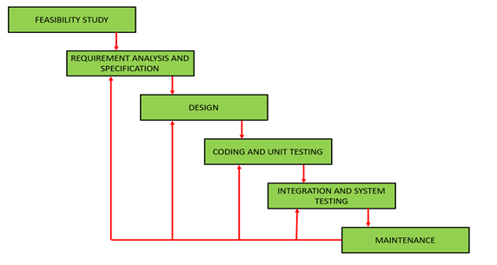

The project will be managed to divide into modules a module to clearly understand how we take next step with the specified time. First we use to gather the requirement from manager and then do all the phases of Software making like after requirement we analyze them and make design of our gathered requirements and divide the modules to our members then do implementation and later we do integration of the modules and last we do test our application and then make it available for our customers. We follow the agile methodology in our project and work on each of single iteration within the time specified. We are using this methodology for Improvement in our project and can adopt change easily in each of single iteration.

## Work Breakdown Structure:

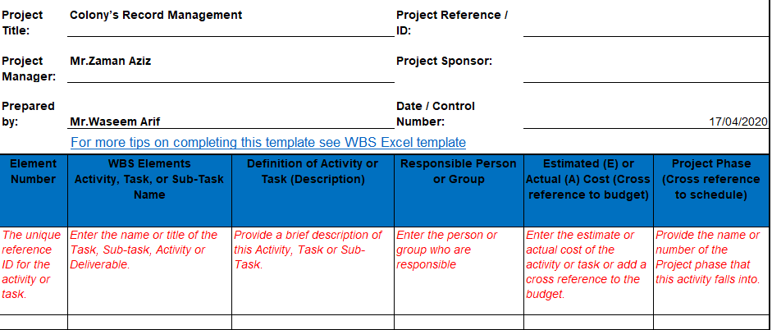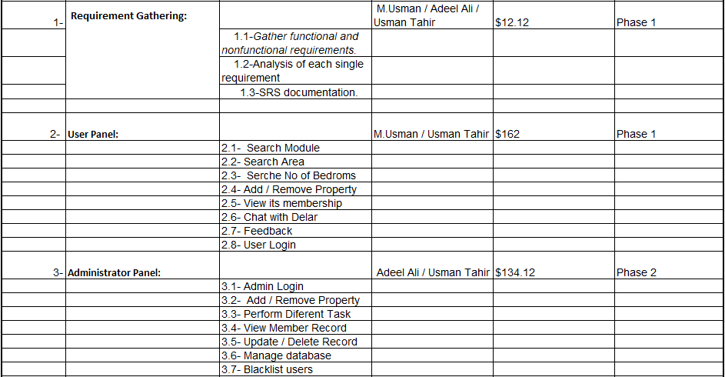

## Work Breakdown Structure:

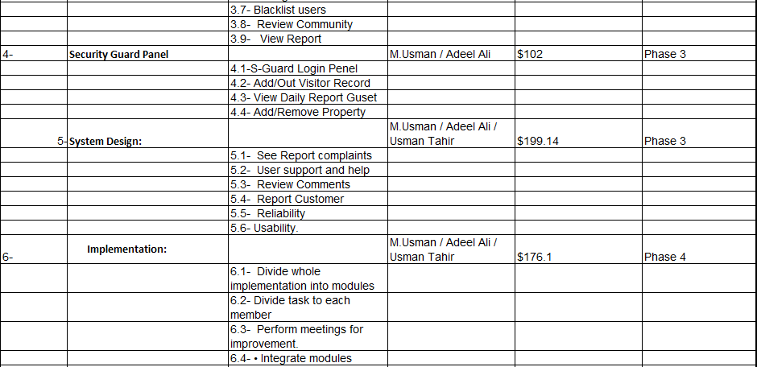

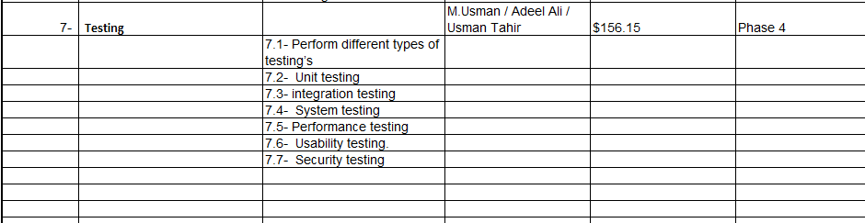

## Roles & Responsibility Matrix:

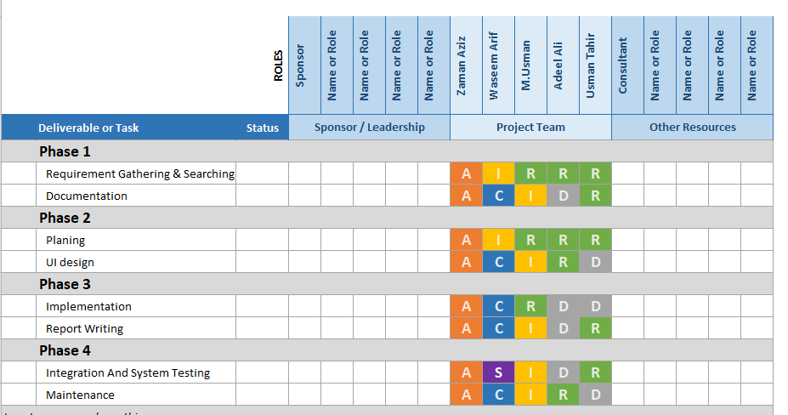

## Gantt Chart:

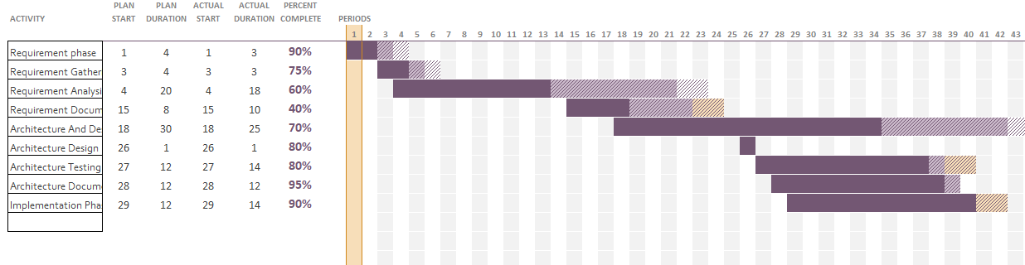

* 1. **Report Outline:**

The main Report of this project is to develop an Online Colony’s Record Management system which is easily accessible to the people. Report outline following that:

* All the system inputs are validated and don’t accept the invalid number or commands.
* Save data smoothly
* With the help of data approaches to the suspect of any incident.
* It generates the pure and clear history of all the related colony members and outsiders.
* All activities track under the rules of colony

**---------------------------------------------ITRATION#1_COMPLETE-------------------------------------------------**

# Chapter 2

# Software Requirement Specifications

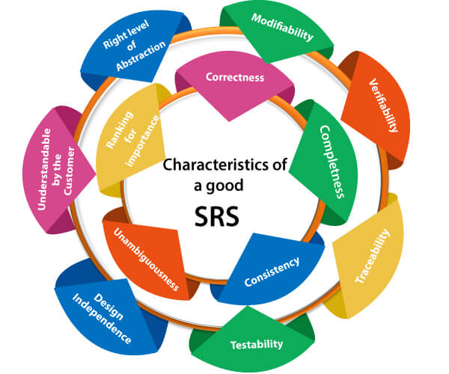

**Chapter 2:** Software Requirement Specifications



## Introduction

## Purpose

This system is developed to manage day-to-day activities of any co-operative colony. Generally, in society all the work is manually. As all work is done on paper so it is very difficult to manage and keep track of all the work expenses in the society. This society management system will computerize all day to day operation in the society. Security system improves. There is no automated system for doing all the things that generally happen in society, so that members can come to know what is happening in society. Residential can also complain about any suspicious activity. A reliable communication. This application entirely works as a notified that notifies about meetings, notices to the residents and about the complaints to the admin. Thus, this application can provide a smarter and efficient way of communication between society residents and higher authorities. It’s having a generalized system architecture where the admin has all the authorities such as to push notices, meetings etc. which will be stored in the database through which the user can absorb this detail.

## Document Conventions

Stander rule of documentation has been followed in the order of standardized the work. In order to create efficient Website in the premises of Project Base Learning. Every module of this project requirement has its own priority.

## Intended Audience and Reading Suggestions

**Audience:**

* User
* Administrator
* Security Guard
* Manager

**Sequence:**

* Introduction, Motivation, Goals, Gap Analysis, Proposed Solution
* Project Plan, WBS, Roles and Responsibility Matrix, Gantt Chart
* Building Methodology

## Product Scope

This project will curb the old practices of maintaining the records, funds, other services, meeting details etc. Digitalization of the housing societies is very important. Social networks play an important role at connecting the people via online reports. Its purposes like social work, business advertisement, and to cherish their hobbies and sports. While registering the resident in the system database. The resident can thus join and leave the group whenever required. The system thus displays the recommendation for house and other security issues with holding records of other commercial and residential peoples separately so as to differentiate and make it clear to the resident.

## References

<https://www.krazytech.com/projects>

* Fundamental of SRS by ramez elmarsi and shamkant b.navathe.
* Instagaint.com
* Researchgate.com
* https://www.criticltools.com

## Overall Description

## Product Perspective

It is a web-based system implementing society management system. Holds the data of society restrictions security guards’ meetings and other housing perspectives.

The Admin allows the user to create their accounts in the system and provide features of and viewing information about society homes etc. Number of users being supported by the system: Though the number is precisely not mentioned but the system is able to support a large number of online users at a time. search is simply local search engine based on key words. Discussion Forum Provides users with a platform to discuss and help each other with their problems. complain system: Allows user to submit his issue to the admin in case his problems are not solved by discussion forums. section: Frequently asked section contains answer of problem which a residential face.

## Product Functions

User will login to the system for performing the tasks. User can logout from system after operation. Forget password and have different filter such as Property Type, Price (PKR), Area (Unit in Marla) and Bedrooms etc. user can sell or view houses or plots of society for sale purchase using block. Admin can post add for property on sale or on rent. Administrator will create security guard login and broadcast massage specific role can allow and block the entry of any specific car person by its number plate or CNIC number. Security guard will login to system to perform his/her tasks. Security Guard may add visitor record and create visitor card according to relevance information. Both security guard and administrator both view daily guest report. Security guard will add the vehicles in and out record. Both security guard and administrator can view the member record, vehicles in and out record, and daily visitors’ reports. Manager can see in admin panel all complains and take action soon. Manager Send broadcast massage specific role. Manager can see in admin panel all complains and take action soon.

## Product Functions

**1. Registration**

|  |  |
| --- | --- |
| **Use Case id** | **01** |
| **Use Case:** | **Registration** |
| **Actors:** | **User, Admin, manager, Security guard** |
| Features: | **Web Form** |
| Scope/Overview: | Create an account for User, Admin, manager, Security guard. Initially he/she open website and then go on sign up screen. Then he/she must provide the first name and last name, phone, email, password, CNIC etc. Then proceed further. |
| **Pre-condition:** | 1. Connection on internet is established(optional) 2. Must have authority to sign up a User, Admin, manager, Security guard. |
| **Scenarios:** | 1. Click on signup button 2. Enter First Name 3. Middle or Last name 4. Phone and Email 5. Address and CNIC 6. Click Sign Up |
| **Alternative scenarios:** | Username, First name AND/OR  Middle name AND/OR  Last name AND/OR  Phone, Email AND/OR  Address, CNIC AND/OR |
| **Post-Conditions:** | 1. Sign up successfully 2. Data is load in database 3. Confirmation message alert when sign up 4. Stay on the same page |

**2. Login**

|  |  |
| --- | --- |
| **Use Case id:** | **02** |
| **Use Case:** | **Login** |
| **Actors:** | **User, Admin, manager, Security guard** |
| Features: | **Web Form** |
| Scope/Overview: | Create an account for User, Admin, manager, Security guard. Initially he/she open website and then go on login screen. Then he/she must provide the username, password. Then proceed further. |
| **Pre-condition:** | 1. Connection on internet is established. 2. Must have authority to add a User, Admin, manager, Security guard. |
| **Scenarios:** | 1. Click on login button 2. Enter username 3. Enter password |
| **Alternative scenarios:** | Username, password AND/OR |
| **Post-Conditions:** | 1. Login successfully 2. Data is load in database 3. Confirmation message alert when sign up 4. Stay on the same page |
| **Use case Cross referenced:** User, Admin, manager, Security guard registered | |

**3.Review System**

|  |  |
| --- | --- |
| **Use Case id** | **03** |
| **Use Case:** | **Review system** |
| **Actors:** | **User, Admin, manager** |
| Features: | **Web Form** |
| Scope/Overview: | If user wants to give about feedback suggestion than they will be post it and after read this feedback system will be response as soon as possible. |
| **Pre-condition:** | 1. Connect to the internet established 2. Admin is logged in 3. Manager is logged in |
| **Scenarios:** | 1. Click on feedback link 2. Enter signup info 3. Enter login info 4. Send & Receive Notifications |
| **Alternative scenarios:** | 1. Signup AND/OR 2. Login AND/OR |
| **Post-Conditions:** | 1. Feedback screen appeared successfully 2. Confirmation message send & receives shown 3. Discuss on related system 4. Positive remarks about feedback & users 5. Stay on the same (user account) page |
| **Use case Cross referenced: none** | |

**4.Booking system**

|  |  |
| --- | --- |
| **Use Case id** | **04** |
| **Use Case:** | **Booking system** |
| **Actors:** | **User** |
| Features: | **Web Form** |
| Scope/Overview: | user check about colony homes & plots block from a block and they can book any one according to their desire. After the booking the admin department will issue them a meeting or appointment date so they can easily communicate and make deals. |
| **Pre-condition:** | 1. Connect to the internet established |
| **Scenarios:** | 1. Click on booking system 2. Enter signup info 3. Enter login info 4. can easily communicate and make deals |
| **Alternative scenarios:** | 1. Signup AND/OR 2. Login AND/OR |
| **Post-Conditions:** | 1. Booking screen appeared successfully |
| **Use case Cross referenced: none** | |

## User Classes and Characteristics

There are 11 kinds of client of this product

**Home**

1. **Search**

* In search module, user can search Rent/Sale property by different filter such as Property Type, Price (PKR), Area (Unit in Marla) and Bedrooms etc.

1. **USER**

* User can search Rent/Sale property by different filter such as Property Type, Price (PKR), Area (Unit in Marla) and Bedrooms etc.
* User can live chat with our management staf.
* User can check the sold rent and reserved areas of colony.
* User can book available property.
* User can give review about colony.
* User can complain directly to the admin if he facing any issue in colony.
* User can report on portal if they feel any emergency activity.
* User should be able to login individually by unique id (email/password).
* User can update his profiles (Picture, nickname, id) from function profile.
* User should be able to change password any time.
* User can logout from the system
* User can be use services of forget password from the system.

1. **Administrator:**

* Admin should be able to login individually by unique id (email/password).
* Administrator can add, delete and update the bio data and vehicle information of colony members in database.
* Admin can check reviews, given by user, and approve and disapprove. Only approved show on the page.
* Admin can check all booking details of sold property, make an appointment with requester.
* Admin can see in admin panel all complains and take action soon.
* Admin Send broadcast massage specific role.
* Admin can check or information about any commercial building and society (plaza, hospitals and school and bank)
* Admin can check the sold rent and reserved areas of colony.
* Admin can allow and block the entry of any specific car person by its number plate or cnic number
* Both security guard and administrator can view the member record, Vehicles in and out record and daily visitors’ reports.
* Administrator can create security guard and manger login.
* Admin can add, delete or edit records of our staff like security guards, gardeners, cleaners, sweepers, imam masjid and admin office staff.
* Admin can update his profile (Picture, nickname, id) from function profile.
* Admin manage property community
* Admin can logout from the system.
* Admin can be use services of forget password from the system.

1. **Security Guard**

* Security Guard may add visitor record in database (id, name, cnic, vehicle number, vehicle type, vehicle destination)
* Security Guard create visitor card according to relevance information.
* Both security guard and administrator both view daily guest report.
* Both security guard and administrator can view the member record, vehicles in and out record, and daily visitors’ reports.
* Security guard can login to system to perform his tasks.
* Security Guard should be able to login individually by unique id (email/password)..
* Security Guard should be able to change password any time.
* Security Guard can logout from the system.

1. **Manager**

* Manager can post adds for property on sale or on rent.
* Manager can create security guard login.
* Both security guard and Manager can view the member record, vehicles in and out record and daily visitors’ reports
* Manager can cheek the sold rent and reserved areas of colony.
* Manager can allow and block the entry of any specific car person by its number plate or CNIC number
* Manager can see in admin panel all complains and take action soon.
* Manager Send broadcast massage specific role.
* Manager can manage property community
* Manager can cheek the sold rent and reserved areas of colony.
* Manager can allow and block the entry of any specific car person by its number plate or CNIC number.
* Manager should be able to login individually by unique id (email/password).
* Manager should be able to change password any time.
* Manager can logout from the system.

1. **Blogs**

* Admin/Manager can post adds for property on sale or on rent with reference to user.
* User can read post with respect to time and date
* Admin can post important announcement for colony
* Admin Send broadcast massage specific role.

1. **Contact**

* The Contact section holds information of colony staff higher management like Admin manager and other authorities like colony administration for vendors and other residential that needed any kind of information or inquire about any matter of whose belongs to colony.

1. **Booking**

* The booking section holds information of colony in which a user check about colony homes & plots block from a block and they can book any one according to their desire. After the booking the admin department will issue them a meeting or appointment date so they can easily communicate and make deals.

1. **Complains**

* The Review section holds complains of colony residential their common or specific problems they would be directly submitted to the manager or admin who takes immediately action to solve the colony issues and maintained the reputation of colony.

1. **Reviews**

* The complaint section holds the user’s perspective their opinions and their experience about the colony it would be public after reviewing by the admin if the review is relevant or not any abusive content the admin approved it will be publishing for everyone.

1. **Visitor record**

* The web has the abilities to store information about the visitor who ever entered in the colony. Its works like it holds the information of visitor like if someone is on a vehicle so the vehicle entry and going time by its car no and visitor CNIC. Moreover, if someone is not on vehicle its entry would be done by its CNIC no.

**About**

* One of the most important sections of our website is the About page, which introduces about our web to the public. should insight to consumers on who we are and what you do and provide a first impression that will welcome new customers. Would holds information about the colony and system.

**Create Responsive Web Page.**

## Operating Environment

* **Environment for connecting to the Internet**
* Required for user registration.
* Web browser
* **Platform**
* Website (Hosting and Domain)
* Windows / Unix / Linux
* **Database**
* SQL
* **For Users:**
* User’s, Admin, Manager, Security Guard’s (of that colony)

## Design and Implementation Constraints

* All records save into the database.
* The “**Colony management system**” is runs 7/24 a day.
* Users can access from any device that has Internet perusing abilities and an Internet association.
* User can be Validate through Gmail id.
* Users must have their right usernames and passwords to access their respected accounts.
* If the credentials meet with saved information into DB then the user will be able to proceed.
* If the credentials do not meet the saved information into DB then the user will be redirected to login, showing the message “Invalid Username or Password”.

## User Documentation

* The following should be taken care of while designing the user interfaces.
* The design or layout of every form will be very clear and very interactive to the user.
* When the user opens the software, the welcome window will appear.
* In the login window the user can easily entered the desired password and login name.
* Then it will give the successfully login message.
* From each and every window the user can easily go to any desired window that is there is will be an absolute and relative linking.
* There will be a proper collection of GUI interface, which will provide better look and feel.
* In the screen layout the background color is very light and the graphics and font style will be in proper manner and well organized.
* In each and every window there will be alert, confirm etc. message box for displaying message.
* The user will be able to search any data from the record by using proper guideline shown in the window & Linux.
* User can easily save its data in to the database and update as their need.
* This software will easily understand able by the user.

## Assumptions and Dependencies

* User has an active internet connection or has access to Website to communicate or use
  + the services of colony system.
* User has a running operating system which supports our Websites.
* Our website will not be violating any internet ethics or cultural rules and won’t be
  + blocked by the Telecom Companies.
* User should know about English may able to use our web.
* We are depending on our hosting service to provide 24/7 online facilities.
* Application interface must be friendly and easy to use.
* Both service and online service can solve more problems of users.
* The search mechanism should be simple and fast.

## External Interface Requirements

## 

## User Interfaces

## Home Page:

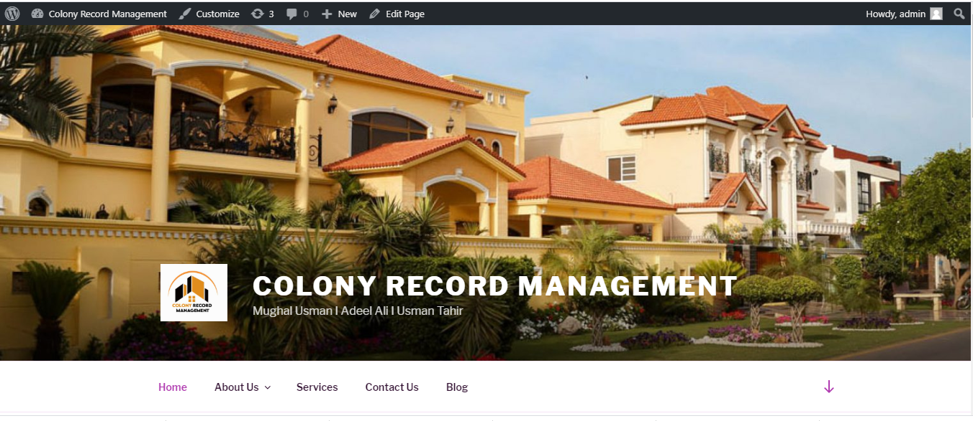

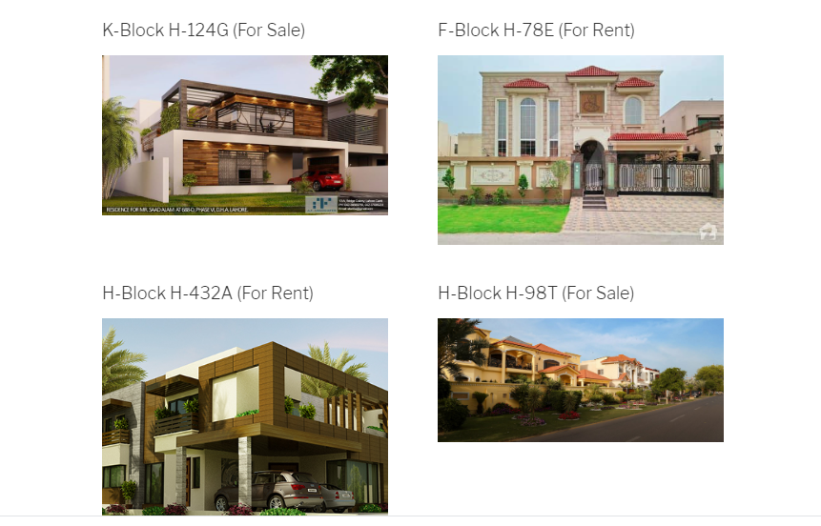

**Security Guard:**

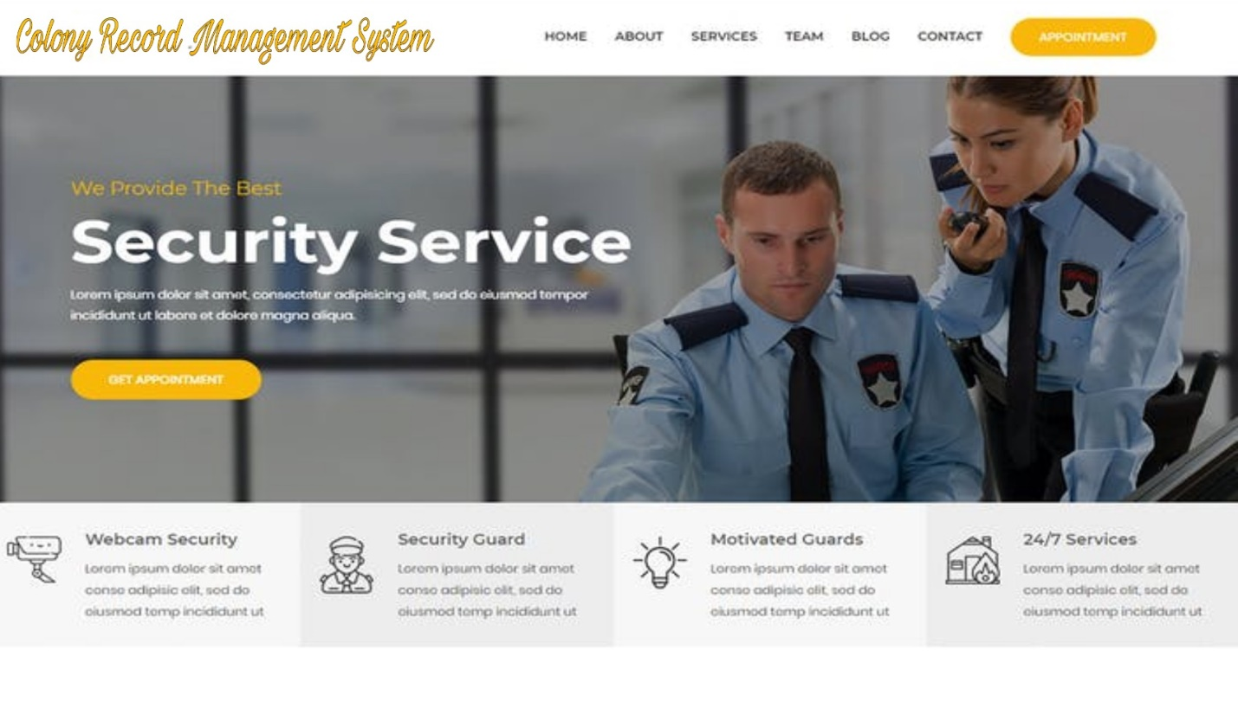

**Login_Page Signup_Page**

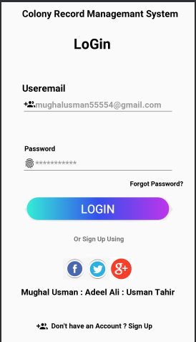 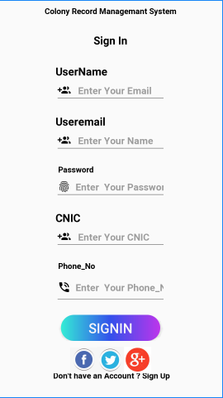

**Administrator :**

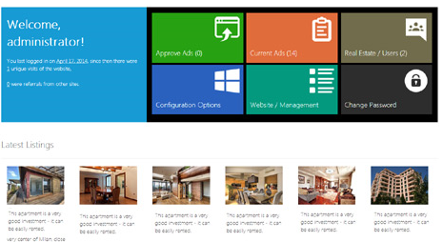

**Manager:**

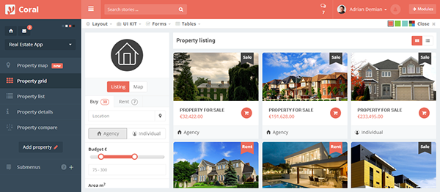

## Software Interfaces

**Operating System:**

Linux, Windows

**Front End:**

HTML/CSS, bootstrap, Angular, JavaScript

**Backend:**

PHP (Laravel) , SQL

## Communications Interfaces

* Internet Connection Required
* Windows, Linux
* Browsers
* HTTP protocol

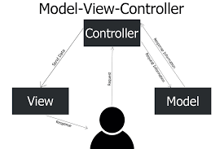

## System Features

# Functional Requirements:

**1- Search**

1. In search module, user can search Rent/Sale property by different filter such as

Property Type, Price (PKR), Area (Unit in Marla) and Bedrooms etc.

**2-User**

1. User can search Rent/Sale property by different filter such as Property Type

Price (PKR), Area (Unit in Marla) and Bedrooms etc.

1. User can check the sold rent and reserved areas of colony.
2. User can live chat with our management staff.
3. User can book available property.
4. User can give review about colony.
5. User can complain directly to the admin if he facing any issue in colony.
6. User can report on portal if they feel any emergency activity.
7. User should be able to registered individually (Name, Email, Password, CNIC,

Phone)

1. User should be able to login individually by unique id (email/password).
2. User can update his profile (Picture, nickname) from function profile.
3. User should be able to change password any time.
4. User can logout from the system
5. User can be use services of forget password from the system.

**3-Administrator:**

1. Admin should be able to login individually by unique id (email/password).
2. Administrator can add, delete and update the bio data and vehicle information

of Colony members in database.

1. Admin can check reviews, given by user, and approve and disapprove. Only

approved show on the page.

1. Admin can check all booking details of sold property, make an appointment with

requester.

1. Administrator can create security guard and manger login
2. Admin can see in admin panel all complains and take action soon.
3. Admin Send broadcast massage specific role
4. Admin can check or information about any commercial building and society

(plaza, hospitals and school and bank)

1. Admin can check the sold rent and reserved areas of colony.
2. Admin can allow and block the entry of any specific car person by its number

Plate Or cnic number.

1. Both security guard and administrator can view the member record, Vehicles in

And Out record and daily visitors’ reports.

1. Admin should be able to change password any time.
2. Admin can add, delete or edit records of our staff like security guards, gardeners,

cleaners, sweepers, imam masjid and admin office staff.

1. Admin manage property community
2. Admin can logout from the system.
3. Admin can be use services of forget password from the system.

**4-Security Guard:**

1. Security Guard may add visitor record in database (id, name, cnic, vehicle

number, vehicle type, vehicle destination)

1. Security Guard create visitor card according to relevance information.
2. Both security guard and administrator both view daily guest report.
3. Both security guard and administrator can view the member record, vehicles in

And Out record, and daily visitors’ reports.

1. Security Guard should be able to change password any time.
2. Security Guard should be able to login individually by unique id(email/password).
3. Security Guard can logout from the system.
4. Security Guard can update his profile (Picture, nickname) from function profile.

**5-Manager:**

1. Manager should be able to login individually by unique id (email/password).
2. Manager can post add for property on sale or on rent.
3. Manager can create security guard login.
4. Both security guard and Manager can view the member record, vehicles in and

out record and daily visitors’ reports.

1. Manager can cheek the sold rent and reserved areas of colony.
2. Manager can allow and block the entry of any specific car person by its number

Plate or CNIC number.

1. Manager can see in admin panel all complains and take action soon.
2. Manager Send broadcast massage specific role.
3. Manager can manage property community
4. Manager can cheek the sold rent and reserved areas of colony.
5. Manager can allow and block the entry of any specific car person by its number

Plate or CNIC number.

1. Manager should be able to change password any time.
2. Manager can logout from the system.
3. Manager can update his profile (Picture, nickname) form function profile.

**6-Blog:**

1. Admin can post add for property on sale or on rent with reference to user.
2. Manager can post add for property on sale or on rent with reference to user.
3. User can read post with respect to time and date.
4. User can comment in post
5. Admin can post important announcement for colony.
6. Admin Send broadcast massage specific role.

**7- Reviews:**

1. The Complaint section holds the user’s perspective their opinions and them

experience about the colony it would be public after reviewing by the admin

or manager.

**8-Booking:**

1. The booking section holds information of colony in which a user check about

colony homes & plots block from a block and they can book any one according

to their desire.

1. After the booking the admin department will issue them a meeting or

appointment date so they can easily communicate and make deals.

**9-Visitor record:**

1. After the booking the admin department will issue them a meeting or

appointment date so they can easily communicate and make deals.

**11-Live Chat:**

1. User can live chat systems that provide 24/7, 365 days a year.
2. Our management staff can live chat with client or customer.
3. L[ive chat](https://acquire.io/live-chat/) platform is a best practice solution when it comes to enhancing the

customer experience. Implement the [best live chat platform](https://acquire.io/live-chat/)  possible to fulfill

your particular business requirements and use the above checklist to help you to

stay on the right track when making your choice.

**10-Complains:**

1. The Review section holds complains of colony residential their common or

specific problems they would be directly submitted to the manager who takes

immediately action to solve the colony issues and maintained the reputation of

colony

**11-Contact:**

1. The Contact section holds information of colony staff higher management like

Admin manager and other authorities like colony administration for vendors and

other residential that needed any kind of information or inquire about any

matter of whose belongs to colony.

**1.0: Registration:**

1. If admin wants to create an account for User. Initially he/she open website and

then go on sign up student screen. Then he/she must provide the first name and

last name, phone, email, password, CNIC etc. Then proceed further.

**1.1: Login:**

1. User must login to access the features of the system.
2. Login functionality should vary differently among customer, manager and

administrator.

1. User can login with the email id and password.
2. Admin can login with email and password assigned to them.
3. Manager can login with id and password assign to him.

|  |  |
| --- | --- |
| **Variables** | **Constraints** |
| User_id | Char/string (min>=3 && max <=35) |
| Password | Char/String(min>=3 && max <=15) |

* 1. **Change password:**

1. Users can change their password by entering the existed password if this recently

entered password matches with the existed password than user should be redirected

to page where he can change his password.

1. Login functionality should vary differently among customer, manager, security guard

and administrator.

1. It may contain.

|  |  |
| --- | --- |
| **Variables** | **Constraints** |
| Existed_pwd | String (min>=3 && max <=15) |
| New_pwd | String (min>=3 && max <=15) |

**1.3 Forget Password:**

1. If user forgets his/her password they would be directed to a page to where they can

recover their password through g mail.

1. It may contain;

**2.0 Logout:**

1. Users should be able to successfully logout from the system.
2. Timed session should e executed after 30 minutes of user log in.
3. It may contain;

**Add managers** :

1. This functionality allows admin to add managers in the system.

|  |  |
| --- | --- |
| **Variables** | **Constraints** |
| Manger_id | String (min>=3 && max <=15) |
| Manager_name | Char/String (min>=3 && max <=15) |

## Other Nonfunctional Requirements

## Performance Requirements

* The system should be easy to use and interactive interface.
* System should be speedy and reliable.
* System should be easily approach able.
* System should be user friendly.
* Performance much important to this system.

## Safety Requirements

* If the network is slow in performance then it can irritate client and client can reject it due to show performance of network.
* If the data on server is not according to the user requirement then it can be rejected by the user.
* If the system is very complex which cannot access by the client easily then it is failure of the system.
* The documentation relating to test planning test design specification, test specification development and test cases development should do accurately and efficiently otherwise it can lead the failure of the test.

## Security Requirements

* Website should be encrypted and secured by https protocol.
* Information of the register user should not be public.
* Non-register user cannot be login.

## Software Quality Attributes

**Reliability:**

* It is necessary for the system to be online 24 hours per day and 7 days per week, regardless of any time-zone.
* The proposed system which the developer designs should be reliable so it efficiently interacts with user. Secure access of confidential data.

**Security:**

* All users must have significant logins and must login according to them.
* To avoid unauthorized access, logins should remain protected in times of system failure.
* No user must have more than one account.

**Usability:**

* Getting registered must not take large amount of time.
* Placing an order must not take more than a minute.
* People with little training shall be able to use the system.

**Portability:**

* The system should be portable to various operating environments.
* If current hosting is not suitable for system, it should be moved to another one.

**User-Friendly:**

* The system should be user friendly in all manners.
* There are some quality attributes which will be provided:

**Availability:**

* It is necessary for the system to be online 24 hours per day and 7 days per week, regardless of any time-zone.

**Maintainability:**

* System will be maintained on regular basis and errors and bugs will be remove.

**Flexibility:**

* System will be flexible according to user.

## Business Rules

There are four kinds of user utilizing the framework,

* User (has authority to book the plots or houses or has rights to complain about any issues also give feedback about the society)
* Security Guard (Has rights to enter data of every entry via their vehicle numbers or their CNIC number also they record the entry and exit time)
* Manager (has authority to delete update Residential records create security guard login

Can do announcement. See all information of colony)

* Administrator / Management (has all rights to manage colony management services Can do announcement. See all information of colony)

## Other Requirements

Other requirement depends upon upcoming system features and requirements.

**---------------------------------------------CHAPTER#2_COMPLETE-------------------------------------------------**

# 

# Chapter 3

# Use Case Analysis



**Chapter 3:**

System Analysis :

The current manual system uses paperwork and direct human language communication by mouth to manage the colony record system. As all work is done on paper so it is extremely hard to oversee and monitor all the work costs in the general public. This general public administration framework will modernize the entire everyday activity in the general public. Security framework improves. There is no computerized framework for doing all the things that for the most part occur in the public arena, with the goal that individuals can come to realize what's going on in the public eye. Private can likewise gripe about any dubious movement. A dependable correspondence.

This application altogether fills in as an informed that advises about gatherings, notification to the inhabitants and about the grumblings to the administrator. In this manner, this application can give a more intelligent and effective method of correspondence between society occupants and higher specialists. It's having a summed-up framework design where the administrator has all the specialists, for example, to push sees, gatherings and so forth which will be put away in the database through which the client can retain this detail. This delays information transmission in the colony record system. This chapter describes the system analysis and models of our colony Record Management System. These models will tell us how the user will interact with the colony system with different features and quality of work and what will be the sequence of activities that occur. We Create Use Cases to describing the whole scenario how it is going to work. Describing actors & their purposes.

## Use Case Model

The below table summarize the use case model of our system.

|  |  |  |
| --- | --- | --- |
| Level – 0 | Level – 1 | Level – 2 |
| Colony Record Management System | User | Search Property  (Rent, Purchase) |
| Booking Property |
| Complain  (Any issue in colony) |
| Feedback/  Review |
|  | Read Add  Property |
| Manager | Has authority to delete update Residential records create security guard loginCan do announcement |
| See all information of colony |
| Administrator | has all rights to manage colony management services Can do announcement. See all information of colony |
|  |  | Create Visitor  Cards |
|  | Security Guard | Has rights to enter data of every entry via their vehicle numbers or their CNIC number also they record the entry and exit time |
|  |  | View Guest  Report |

* 1. **Use Case Diagrams**

1. **Login Use case:**

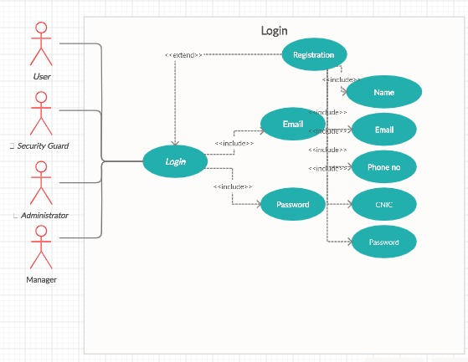

1. **Logout Use case:**

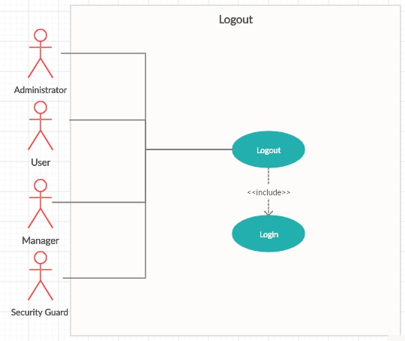

1. **User Use case:**

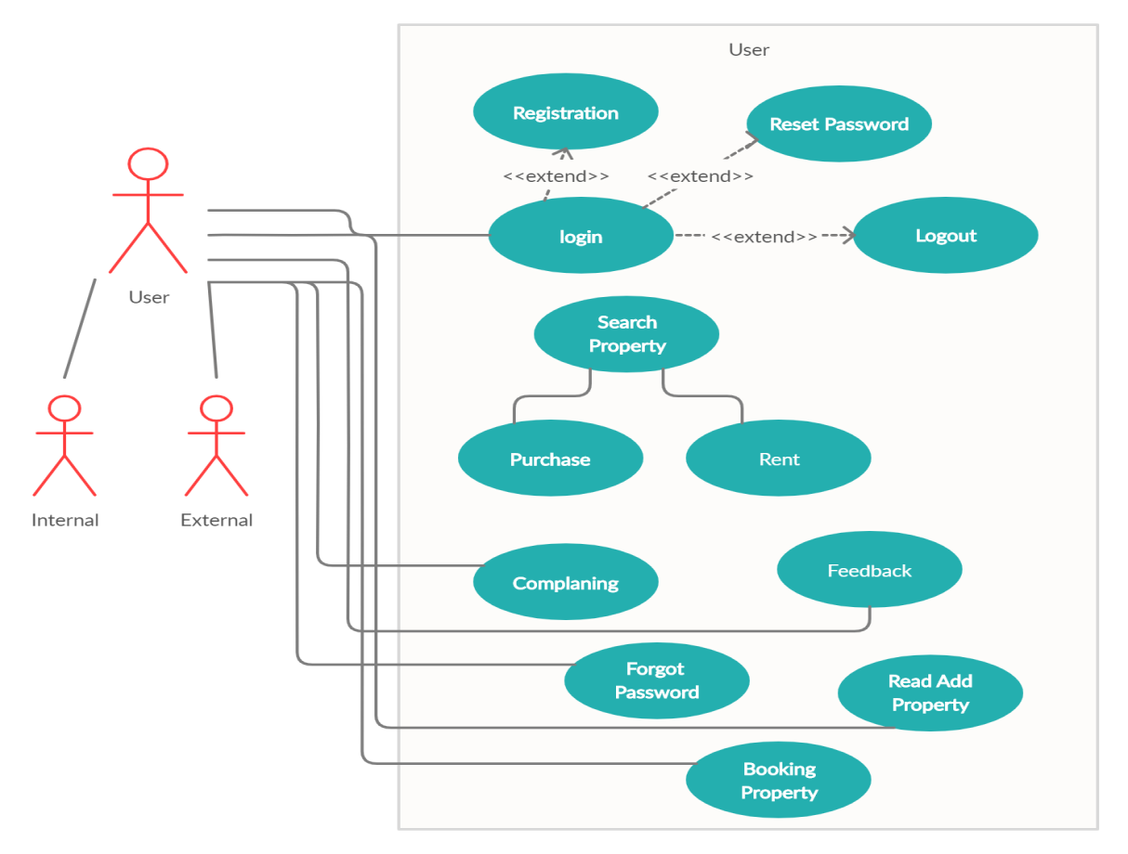

1. **Admin Use case**

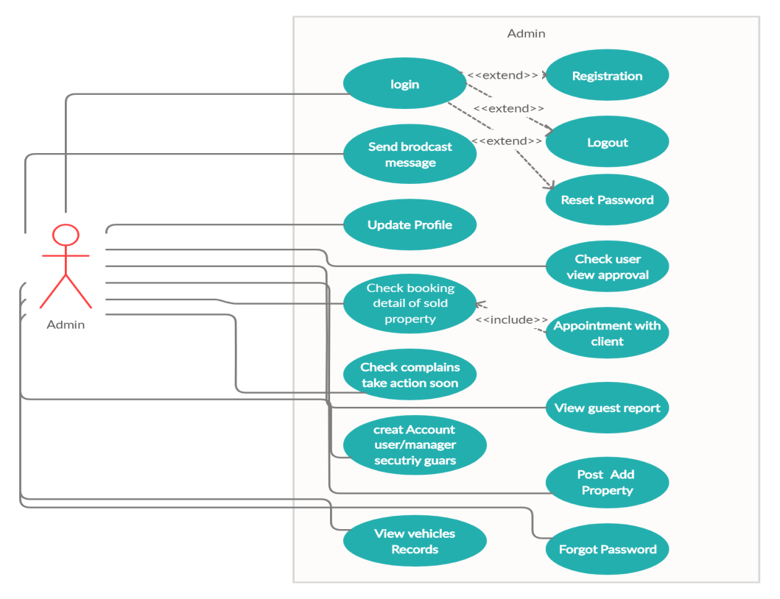

1. **Manager Use case:**

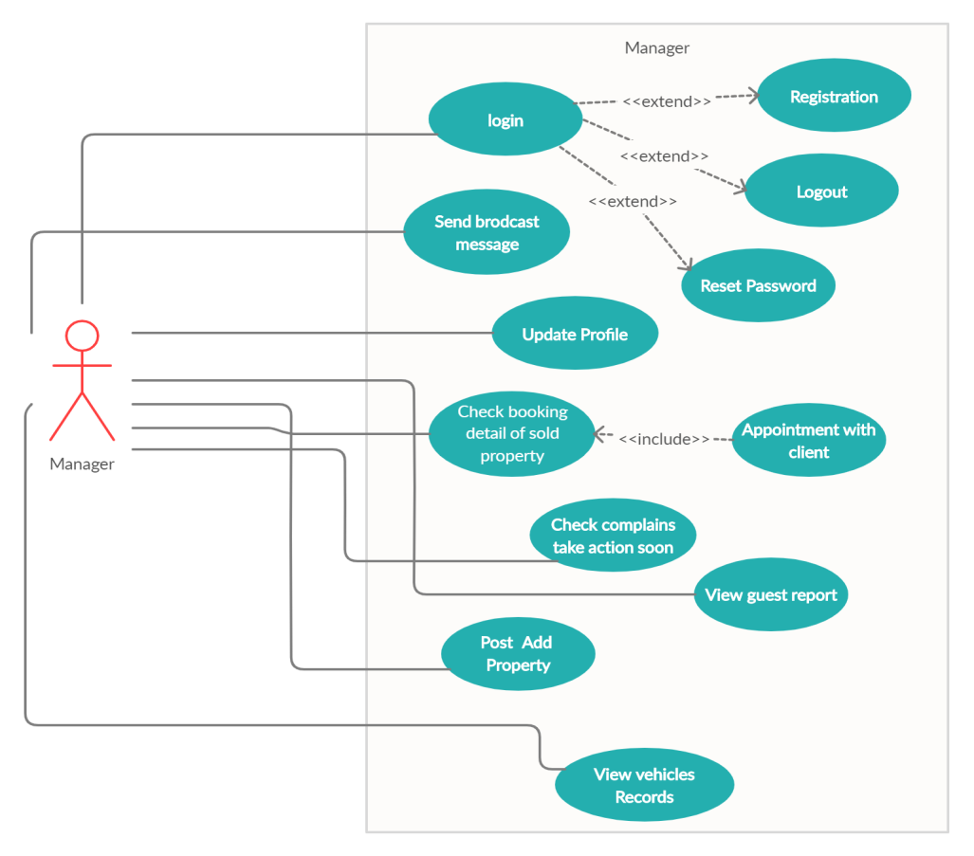

1. **Security Guard Use case:**

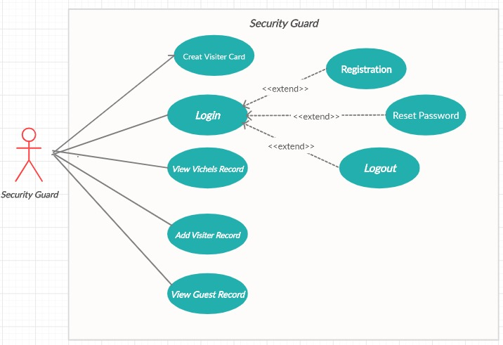

**8- Full use case diagram:**

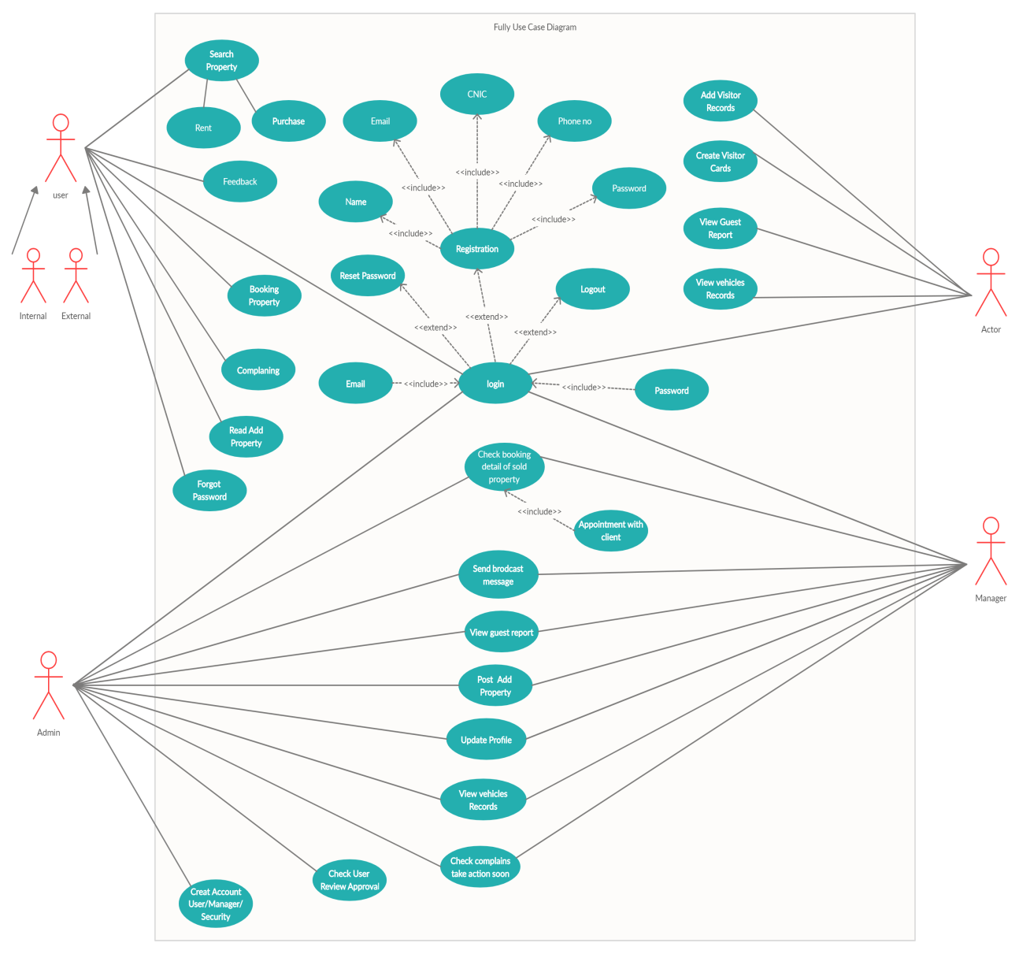

## Fully Dressed Use Cases:

1. **Registration:**

|  |  |
| --- | --- |
| **Use Case id** | **01** |
| **Use Case:** | **Registration** |
| **Actors:** | **User, Admin, manager, Security guard** |
| Features: | **Web Form** |
| Scope/Overview: | Create an account for User, Admin, manager, Security guard. Initially he/she open website and then go on sign up screen. Then he/she must provide the first name and last name, phone, email, password, CNIC etc. Then proceed further. |
| **Pre-condition:** | 1. Connection on internet is established(optional) 2. Must have authority to sign up a User, Admin, manager, Security guard. |
| **Scenarios:** | 1. Click on signup button 2. Enter First Name 3. Middle or Last name 4. Phone and Email 5. Address and CNIC 6. Click Sign Up |
| **Alternative scenarios:** | Username, First name AND/OR  Middle name AND/OR  Last name AND/OR  Phone, Email AND/OR  Password, CNIC AND/OR |
| **Post-Conditions:** | 1. Sign up successfully 2. Data is load in database 3. Confirmation message alert when sign up 4. Stay on the same page |

1. **Login:**

|  |  |
| --- | --- |
| **Use Case id:** | **02** |
| **Use Case:** | **Login** |
| **Actors:** | **User, Admin, manager, Security guard** |
| Features: | **Web Form** |
| Scope/Overview: | Create an account for User, Admin, manager, Security guard. Initially he/she open website and then go on login screen. Then he/she must provide the username, password. Then proceed further. |
| **Pre-condition:** | 1. Connection on internet is established. 2. Must have authority to add a User, Admin, manager, Security guard. |
| **Scenarios:** | 1. Click on login button 2. Enter username 3. Enter password |
| **Alternative scenarios:** | Username, password AND/OR |
| **Post-Conditions:** | 1. Login successfully 2. Data is load in database 3. Confirmation message alert when sign up 4. Stay on the same page |
| **Use case Cross referenced:** User, Admin, manager, Security guard registered | |

**3. Create Visitor Card**

|  |  |
| --- | --- |
| **Use Case id:** | **03** |
| **Use Case:** | Create Visitor Card |
| **Actors:** | **Security Guard** |
| Features: | **Web Form** |
| Scope/Overview: | If Security guard wants to create visitor card then they follow procedure which describe in this use case. Initially they open website and then go on login screen. Put their valid details visitor Name , CNIC , Car no and address etc. |
| **Pre-condition:** | 1. Connect to the internet established 2. Security guard is logged in |
| **Scenarios:** | 1. Click on create visitor card 2. Enter the details visitor |
| **Alternative scenarios:** | 1. Signup AND/OR 2. Login AND/OR |
| **Post-Conditions:** | Visitor card create successfully |

**4. Complains:**

|  |  |
| --- | --- |
| **Use Case id** | **04** |
| **Use Case:** | **Complains** |
| **Actors:** | **User , Admin, Manager** |
| Features: | **Web Form** |
| Scope/Overview: | If user complain to manager then they follow procedure which describe in this use case then proceed further complains section holds complains of colony residential their common or specific problems they would be directly submitted to the manager who takes immediately action to solve the colony issues and maintained the reputation of colony. |
| **Pre-condition:** | 1. Connection on internet is established. 2. Must have authority to sign up a user. 3. Connect to the internet established. 4. User remember their login username, email and password. |
| **Scenarios:** | 1. Click on Login Link 2. Enter Username 3. Enter Password 4. Write Complain 5. By some query answer |
| **Alternative scenarios:** | 1. Username is invalid 2. Password is invalid 3. Complain not send 4. Query not working |
| **Post-Conditions:** | 1. Login successfully 2. Complain send successfully 3. Session established & get started 4. Popup message alert 5. Redirect to Home Page after vote cast |

**5. Visitor report:**

|  |  |
| --- | --- |
| **Use Case id:** | **05** |
| **Use Case:** | **Visitor report** |
| **Actors:** | **Admin, Security Guard ,Manager** |
| Features: | **Web Form** |
| Scope/Overview: | If admin , security guard and Manager can view the member record, vehicles in and out record and daily visitors’ reports. |
| **Pre-condition:** | 1. Connect to the internet established 2. Admin , manager and security guard is logged in |
| **Scenarios:** | 1. Click on print report link 2. Check visitor details 3. Print Report |
| **Alternative scenarios:** | 1. Signup AND/OR 2. Login AND/OR |
| **Post-Conditions:** | 1. Generate report successfully 2. Preview is shown 3. Printed web page display 4. Stay on the same (user account) page |

**6.Booking system:**

|  |  |
| --- | --- |
| **Use Case id** | **06** |
| **Use Case:** | **Booking system** |
| **Actors:** | **User** |
| Features: | **Web Form** |
| Scope/Overview: | User check about colony homes & plots block from a block and they can book any one according to their desire. After the booking the admin department will issue them a meeting or appointment date so they can easily communicate and make deals. |
| **Pre-condition:** | 1. Connect to the internet established |
| **Scenarios:** | 1. Click on booking system 2. Enter signup info 3. Enter login info 4. can easily communicate and make deals |
| **Alternative scenarios:** | 1. Signup AND/OR 2. Login AND/OR |
| **Post-Conditions:** | 1. Booking screen appeared successfully |
| **Use case Cross referenced: none** | |

**7.Create Login Account(Management Colony):**

|  |  |
| --- | --- |
| **Use Case id:** | **07** |
| **Use Case:** | **Create Login Account** |
| **Actors:** | **Admin** |
| Features: | **Web Form** |
| Scope/Overview: | If administrator wants to create login account then they follow procedure which describe in this use case. Initially they open website and then go on login screen. Put their valid details after they will create security guard and manger login. |
| **Pre-condition:** | 1. Connect to the internet established 2. Admin is logged in |
| **Scenarios:** | 1. Click on create account 2. Enter the details management |
| **Alternative scenarios:** | 1. Signup AND/OR 2. Login AND/OR |
| **Post-Conditions:** | 1. Account create successfully 2. Check Login |

1. **Feedback:**

|  |  |
| --- | --- |
| **Use Case id** | **08** |
| **Use Case:** | **Feedback** |
| **Actors:** | **User, Admin, manager** |
| Features: | **Web Form** |
| Scope/Overview: | If user wants to give about feedback suggestion than they will be post it and after read this feedback system will be response as soon as possible. |
| **Pre-condition:** | 1. Connect to the internet established 2. Admin is logged in 3. Manager is logged in |
| **Scenarios:** | 1. Click on feedback link 2. Enter signup info 3. Enter login info 4. Send & Receive Notifications |
| **Alternative scenarios:** | 1. Signup AND/OR 2. Login AND/OR |
| **Post-Conditions:** | 1. Feedback screen appeared successfully 2. Confirmation message send & receives shown 3. Discuss on related system 4. Positive remarks about feedback & users 5. Stay on the same (user account) page |
| **Use case Cross referenced: none** | |

**9. Broadcast Message:**

|  |  |
| --- | --- |
| **Use Case id** | **09** |
| **Use Case:** | **Broadcast Message** |
| **Actors:** | **Admin, Manager** |
| Features: | **Web Form** |
| Scope/Overview: | If administrator and manager wants to send broadcast massage for specific role then they follow procedure which describe in this use case. Initially they open website and then go on login screen. Put their valid details after they will send both broadcast massage specific role . |
| **Pre-condition:** | 1. Connection on internet is established. 2. Must have authority to sign up a user. 3. Amin and manager remember their login username, email and password. |
| **Scenarios:** | 1. Click on Login Link 2. Enter Email 3. Enter Password 4. Write message 5. By some query answer |
| **Alternative scenarios:** | 1. Username is invalid 2. Password is invalid 3. Broadcast message not send 4. Query not working |
| **Post-Conditions:** | 1. Login successfully 2. Broad Cast message send successfully 3. Session established & get started 4. Popup message alert 5. Redirect to Home Page after vote cast |

**10. Search by plot home size Marla or block:**

|  |  |
| --- | --- |
| **Use Case id** | **10** |
| **Use Case:** | **Search by plot home size Marla or block** |
| **Actors:** | **User** |
| Features: | **Filter options** |
| Scope/Overview: | The Client can search Homes, Plot, shops and blocks and the other sections of colony saved by admins. Click on search button, search the data filter it like view only colony 3 Marla plot etc. |
| **Pre-condition:** | 1. Internet Connectivity 2. Successfully Login |
| **Scenarios:** | 1. Click on search button 2. search the data filter 3. Apply filter 4. Select your desire |
| **Alternative scenarios:** | Username AND/OR  Password AND/OR  Invalid filter AND/OR |
| **Post-Conditions:** | 1. Data is load from database 2. user view results successfully 3. Select your choice. |

**11.Manage appointments:**

|  |  |
| --- | --- |
| **Use Case id** | **11** |
| **Use Case:** | Manage appointments |
| **Actors:** | **User , Admin.** |
| Features: | **Conformation Appointments message** |
| Scope/Overview: | Press the view appointments button then manage button to approve or reject the appointment according to their schedule.  In the case of accepting appointment the administration or receptionist will have to mention the time. |
| **Pre-condition:** | 1. Internet Connectivity 2. Successfully Login 3. Booking |
| **Scenarios:** | 1. Press the view appointments button 2. Manage button to approve or reject 3. In the case of accepting appointment the admin will have to mention the time. |
| **Alternative scenarios:** | Username AND/OR  Password AND/OR  Invalid filter AND/OR  Booking AND/OR |
| **Post-Conditions:** | 1. Successfully appointment fixed message. 2. Logout |

**12-Booking Response**

|  |  |
| --- | --- |
| **Use Case id** | **12** |
| **Use Case:** | Booking Response |
| **Actors:** | **User , Admin.** |
| Features: | **Conformation message** |
| Scope/Overview: | A message will pop up on screen about Cancellation and confirmation  for booking with details of home and plot including sell or reservation details. |
| **Pre-condition:** | 1. Internet Connectivity 2. Successfully Login 3. Booking |
| **Scenarios:** | 1. Press the Conform booking button 2. Manage button to approve or reject 3. In the case of accepting appointment the admin will have to mention the time. |
| **Alternative scenarios:** | Username AND/OR  Password AND/OR  Invalid filter AND/OR  Booking AND/OR |
| **Post-Conditions:** | 1. Booking Conformation message 2. Successfully appointment fixed message. 3. Logout |

**13- Date and Time**

|  |  |
| --- | --- |
| **Use Case id** | **13** |
| **Use Case:** | Date and Time |
| **Actors:** | **User.** |
| Features: | User wants to see Date and Time |
| Scope/Overview: | User go to the conform Booking after cheek appointment and make sure appointment date and time. A informative form will be appear in front of User in witch user can see the date and time of appointment. |
| **Pre-condition:** | * + 1. Internet Connectivity     2. Successfully Login     3. User must Book plot or house |
| **Scenarios:** | 1. User Selects the “Feedback Manage button to approve or reject 2. A form will be appear in front of User 3. User can view date and time and make conformed |
| **Alternative scenarios:** | Username       AND/OR  Password        AND/OR  Booking          AND/OR |
| **Post-Conditions:** | Successful appointment date and time done. |

**14- Send Reports**

\

|  |  |
| --- | --- |
| **Use Case id** | **14** |
| **Use Case:** | Send Reports |
| **Actors:** | **User.** |
| Features: | User send reports to Admin |
| Scope/Overview: | User Selects the “Feedback” then User will generate Report against the Office behavior Send Report to Respective Admin. |
| **Pre-condition:** | * + 1. Internet Connectivity     2. Successfully Login     3. User must generate the Alert |
| **Scenarios:** | 1. User Selects the “Feedback Manage button to approve or reject 2. User will generate Report against the Office behavior 3. Send Report to Respective Admin. |
| **Alternative scenarios:** | Username       AND/OR  Password        AND/OR  Appointment  AND/OR |
| **Post-Conditions:** | 1. Success message, 2. Report Sent |

**---------------------------------------------ITRATION#2_COMPLETE-------------------------------------------------**

# Chapter 4

# System Design

**Chapter 4:** System Design

[Paragraph Text 12 pt, Calibri, 1.5 Line Spacing, Justified]

[*Between 4 to 8 lines describe what is this chapter all about*]

## Architecture Diagram

[Paragraph Text 12 pt, Calibri, 1.5 Line Spacing, Justified]

## Domain Model

[Paragraph Text 12 pt, Calibri, 1.5 Line Spacing, Justified]

## Entity Relationship Diagram with data dictionary

[Paragraph Text 12 pt, Calibri, 1.5 Line Spacing, Justified]

## Class Diagram

[Paragraph Text 12 pt, Calibri, 1.5 Line Spacing, Justified]

## Sequence / Collaboration Diagram

[Paragraph Text 12 pt, Calibri, 1.5 Line Spacing, Justified]

## Operation contracts

[Paragraph Text 12 pt, Calibri, 1.5 Line Spacing, Justified]

## Activity Diagram

[Paragraph Text 12 pt, Calibri, 1.5 Line Spacing, Justified]

## State Transition Diagram

[Paragraph Text 12 pt, Calibri, 1.5 Line Spacing, Justified]

## Component Diagram

[Paragraph Text 12 pt, Calibri, 1.5 Line Spacing, Justified]

## Deployment Diagram

[Paragraph Text 12 pt, Calibri, 1.5 Line Spacing, Justified]

## Data Flow diagram [*only if structured approach is used - Level 0 and 1*]

[Paragraph Text 12 pt, Calibri, 1.5 Line Spacing, Justified]

# Chapter 5

# Implementation

**Chapter 5:** Implementation

[Paragraph Text 12 pt, Calibri, 1.5 Line Spacing, Justified]

[*Between 4 to 8 lines describe what is this chapter all about*]

## Important Flow Control/Pseudo codes

[Paragraph Text 12 pt, Calibri, 1.5 Line Spacing, Justified]

## Components, Libraries, Web Services and stubs

[Paragraph Text 12 pt, Calibri, 1.5 Line Spacing, Justified]

## Deployment Environment

[Paragraph Text 12 pt, Calibri, 1.5 Line Spacing, Justified]

## Tools and Techniques

[Paragraph Text 12 pt, Calibri, 1.5 Line Spacing, Justified]

## Best Practices / Coding Standards

[Paragraph Text 12 pt, Calibri, 1.5 Line Spacing, Justified]

## Version Control

[Paragraph Text 12 pt, Calibri, 1.5 Line Spacing, Justified]

# Appendices

# Appendix A: Information / Promotional Material

[Paragraph Text 12 pt, Calibri, 1.5 Line Spacing, Justified]

[*Between 4 to 8 lines describe what is this appendix all about*]

* 1. **Broacher**

* 1. **Flyer**
  2. **Standee**
  3. **Banner**
  4. **First Level heading [16 pt, Calibri, Bold, Left aligned]**

[Paragraph Text 12 pt, Calibri, 1.5 Line Spacing, Justified]

* + 1. **Second level heading [14 pt, Calibri, Bold, Left aligned]**

[Paragraph Text 12 pt, Calibri, 1.5 Line Spacing, Justified]

* + - 1. **Third level heading [12 pt, Calibri, Bold, Left aligned]**

[Paragraph Text 12 pt, Calibri, 1.5 Line Spacing, Justified]

# Appendix [no.]: Appendix Title

[Paragraph Text 12 pt, Calibri, 1.5 Line Spacing, Justified]

[*Between 4 to 8 lines describe what is this chapter all about*]

* 1. **First Level heading [16 pt, Calibri, Bold, Left aligned]**

[Paragraph Text 12 pt, Calibri, 1.5 Line Spacing, Justified]

* + 1. **Second level heading [14 pt, Calibri, Bold, Left aligned]**

[Paragraph Text 12 pt, Calibri, 1.5 Line Spacing, Justified]

* + - 1. **Third level heading [12 pt, Calibri, Bold, Left aligned]**

[Paragraph Text 12 pt, Calibri, 1.5 Line Spacing, Justified]

# Reference and Bibliography

**Reference and Bibliography**

[1] M. Sher, M. Rehman, “*Title of the Paper*” Conference name/Journal Name, Edition, Volume, Issue, ISBN/ISSN, PP, Publisher/City-Country, Year.

[2] ……

# Index

**Index**

**[A]**

**[B]**

**[C]**